IOP-OANMO-530836012
5GHz 8dBi Omni Antenna

Electrical Specification
Frequency range | 5150MHz – 5350MHz
Gain | 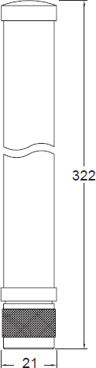  8 dBi
VSWR | 2 : 1 Max.
Polarization | Linear, Vertical
HPBW / Horizontal | 360°
HPBW / Vertical | 12°
Electrical downtilt | 0°
Power handing | 5W (cw)
Impedance | 50 Ohms
Connector | N Plug
Environmental & Mechanical Characteristics
Survival wind speed | 216Km/hr
Temperature | -40℃ to +80℃
Humidity | 95% @ 55℃
Radome color | Gray - white
Radome material | Fiber glass, UV resistant
Weight | 110g
Dimensions | Φ22 × 325 mm

